

MS Word Training- Session-3: Part-2

Page & Section Breaks and Headers & Footers
Version: 1.0
February 2009
Copyright Information:
This document is the sole property of AIG Inc. All rights reserved. No part of this document may be reproduced, stored in a retrieval system, translated, transcribed, or transmitted in any form or by any means, without the prior written permission of AIG Systems Solutions (AIGSS).
Document Information
S.No | Document Title | Base Version No. | Author | Contact Email ID | Date Of Release
1 | Page & Section Breaks and Headers & Footers | 1.0 | Deepika Datta | deepika.datta@aig.com | February 2009
Revision History
S.No | Version No. | Date Of Release | Author (s) | Affected Section(s) | History of Changes | Approver

Table of Contents
1 Line and Page Breaks 4
1.1 Line Breaks 4
1.1.1 Introduction 4
1.1.2 Insert a manual line break 4
1.1.3 Pagination 4
1.2 Tabs 5
1.2.1 Setting tabs on the horizontal ruler 6
1.2.2 Adjusting tab stops on the horizontal ruler 7
1.2.3 Clearing tab stops 7
2 Headers & Footers 8
2.1 Introduction 8
2.2 Creating header - footer 8
2.3 Editing or removing a header or footer 8

Line and Page Breaks

Line Breaks

Introduction
Word thinks it can start a new line anywhere it finds a space or a hyphen. If you need to keep two words together on the same line (e.g. Mr()Smith, or 8()October) you can ‘glue’ them together by using a hard space instead of an ordinary one. Hold both the Ctrl and Shift keys down when pressing the spacebar or the hyphen key.
Note: You can see whether you have used a Hard Space or not by clicking the Show/Hide button on the toolbar. The hard space will be shown as a small circle instead of a dot as shown here:

Insert a manual line break
A manual line break ends the current line and continues the text on the next line. For example, suppose your paragraph style includes extra space before each paragraph. To omit this extra space between short lines of text, such as those in an address block or a poem, insert a manual line break after each line instead of pressing Enter.
- Click where you want to break a line of text.
- Press Shift+Enter.
Manual line breaks are formatting marks that aren't normally visible in your document. If you want to view these breaks, turn on the formatting marks by clicking Show/Hide on the Standard toolbar. The manual line break character indicates a manual line break, e.g.:
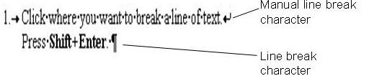

Pagination
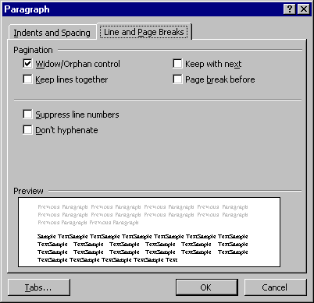
Settings on the Line and Page Breaks tab in the Paragraph dialog box primarily control how Word will insert automatic page breaks.
To create a new page you can press Ctrl+Enter. However, unless you are starting a new chapter, or it is essential that the following text be on a new page, it is better to let Word decide where a new page should start. There are occasions when you will need to let Word know that you need to keep certain sections of text together on the same page. This can be done in one of the following ways:
Widow/orphan control –
As this is a very useful option, most installations of Word will switch it on for all paragraphs by default. It prevents page breaks falling right after the first line of a paragraph leaving the first line stranded at the bottom of a page (i.e. a widow). An orphan is where a page break falls just before the last line of a paragraph, leaving the final line stranded at the top of the next page.
Keep lines together –
This option prevents Word from placing a page break in a paragraph or list.
Keep with next –
This ensures that the selected paragraph(s) will never be split by page breaks. It is often used with Heading styles to ensure that they don’t appear on their own at the bottom of a page – if the following paragraph appears on the next page, the heading will be moved too.
Page break before –
This option would cause the selected heading (or paragraph) always to appear at the top of a new page.

Tabs
A tab stop is a measured position for placing and aligning text at a specific place on a page. It takes its name from the tabulation stops used on manual typewriters. Tabs can be used to set out text and figures in columns. Tabs are often replaced by tables for layout purposes.
Note
A common error is to use the Spacebar key to create columns. This will never be really exact and if you need to edit the text later the layout may be affected.
Pre-set tab markers are shown here.
Tab stops are pre-set for you at 1.27cm (0.5") intervals from the left margin. By pressing Tab the insertion point moves to the next tab stop in the current paragraph. Pre-set tab stops are shown as little grey shaded marks on the bottom edge of the ruler. You can, however, set your own tab stops.

Word has four main types of tab alignment, as illustrated here:

Left Centre Right Decimal
Friday May 1234 11.22
Wednesday February 12345 111.222
Sunday June 123456 1111.2222
You can also set tabs to display leader dots between columns, or to place vertical lines between columns. For example:
Animals
Pets Cats 6
Dogs 23
Farm animals Sheet 31
Cows 40
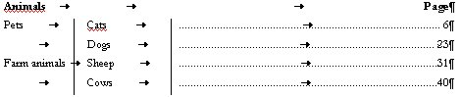
Note: You can see where the tab key has been pressed in a document by clicking the Show/Hide button on the toolbar. For example:
Tabs are applied to the paragraph you are currently working in or all paragraphs that have been selected.
Note: It is important to ensure the cursor is placed correctly before setting your tabs. They will only be effective from that point onwards.
Setting tab stops in the Tabs dialog box
- Select the required paragraph(s).
- On the Format menu click Tabs. The Tabs dialog box is displayed.
- Enter a measurement value for a tab stop in the Tab stop position box or select the existing tab stop that you wish to modify.
- Specify the required alignment in the Alignment area and leader style (if any) in the Leader area, and click Set.
- Repeat until all the tab stops are set and click OK.
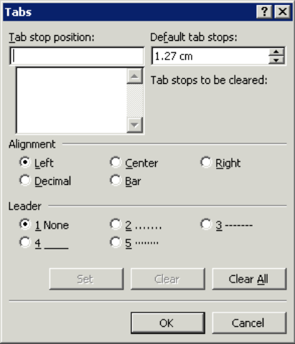
Changes default tab stop for the entire document.
Enter a new tab stop value here.
Use these options to select tab stop alignment.
Use these options to select a tab leader for the selected tab stop.
Use these buttons to set or clear a selected tab stop.
Clears all custom tab stops for selected paragraph(s).
Select existing tab stops here.

Setting tabs on the horizontal ruler
You can choose the type of tab using the tab button on the left of the ruler.
- Place the cursor at the beginning of the section you want the tabs to be effective for, or, if text already exists, select the relevant text.
- Click the Tab button at the far left of the horizontal ruler until the type of tab you require is displayed. Note that it is also possible to set Hanging and First Line Indents using the tab button.
Tab buttons | To select
 | Left aligned tab stops
 | Centred aligned tab stops
 | Right aligned tab stops
 | Decimal aligned tab stop
 | Bar tab (places a vertical line at the tab position)
 | Hanging indent
 | First line indent
- On the ruler, click where you want to set a tab stop.
Left-aligned tab stop
Centre-aligned tab stop
Right-aligned tab stop
Decimal-aligned tab stop
Tab alignment button
Tabs are displayed on the horizontal ruler as shown above.
Note: Each paragraph can have its own set of tab stops. When a paragraph is selected, the tab stops are displayed on the ruler. If two paragraphs with differing tab stops are selected, the tabs on the ruler are greyed out to indicate the conflicting definitions.

Adjusting tab stops on the horizontal ruler
- Select the paragraph(s).
- Click and drag the appropriate marker along the ruler and release it.

Clearing tab stops
- Select the paragraph(s) in which you want to clear a tab stop.
- On the Format menu click Tabs.
- In the Tab stop position list click the tab stop to be deleted and click Clear. To delete all tab stops click Clear All or click and drag the tab markers off the ruler.
Note: Using tab stops to produce column formats is very much a product of procedures derived from the days of the manual typewriter. For simple columns they are still quick and useful. However, more complex layouts are often more easily handled in Word by using tables.
It is possible to use tab stops inside tables, for example, to align decimal points, or to insert leader dots. However, it is necessary to press Ctrl+Tab rather than just pressing the Tab key, as the latter would just take you to the next cell in the table. See page Error: Reference source not found for details of creating and using tables

Headers & Footers

Introduction
Header or footer is text (or graphics) printed at the top (header) or bottom (footer) of a page. It is usually repeated on every page in the document. This manual has a footer that includes a page number and other information. Each header and footer appears as a text box at the top or bottom of the document with its own tab settings ready for text entry. A toolbar also appears when headers and footers are activated which includes a number of buttons to facilitate working with headers and footers and make the insertion of page numbers, and other fields (such as Date and Time) a straightforward task.

Creating header - footer
- On the View menu, click Header and Footer. The Header and Footer toolbar is displayed.
Insert Number
of Pages

Insert Page Number

Insert Date

Insert Time

Switch between Header and Footer

Figure 3

Figure 3

Insert Autotext Entry
Format
Page
Number

Page Setup

Show/Hide
Document
Text

Show
Next

Show Previous

Same as Previous

Text can be entered in the header or footer area and formatting applied to it in the same way as in the main document.
- AutoText entries and fields (including page numbers) can be inserted automatically into the header/footer by clicking on the appropriate options on the Header and Footer toolbar (see above).
- Click on the Page Number button to insert page numbers.
- Click on the Switch between header and footer button to switch from one to the other.
- Click on the Close button or double-click anywhere in the main document area i.e. outside the header or footer to finish editing.

Editing or removing a header or footer
- On the View menu click Header and Footer, or double-click in the header/footer area. The header/footer box is displayed and ready to be edited. If necessary use Switch between Header and Footer to switch to the footer.
- Make any amendments as necessary.
- Click on the Close button, or double-click anywhere in the main document area i.e. outside the header or footer to finish editing.

